**The Application of Optimization Techniques to Explore Free Throw Performance**

J. Mortensen[1] and J. Porter[2]

Brigham Young University, Provo, UT, 84604

# Abstract

### Arm motion has been diversely studied in the field of biomechanics. The resources and technology available for studying the motions of the body in sport related activities have been used to benefit athletes. The role of optimization has been used in the past to improve athletic form. Computer simulations imitate the mechanics of the body to provide realistic explanations as to why certain motions carry out better performance. However, optimization can also be used as a tool to understand how a player must practice in order to obtain control and reliability during performance. This study was comprised of two optimization analyses to determine the best approach to shooting a free throw. Based on the average height statistics of NBA players in 2015, the optimal path of the arm was determined based on the most reliable trajectory of the ball to score a foul shot. Because of the complexity of the arm, simulating the skeletal and muscular structures of the arm were simplified in a 3-dimensional model. Muscular activity was incorporated in the design in order to provide an analytical perspective of reliability of a shot contrasted with repeatability. Preliminary results suggested that the traditional free throw shot was likely the most optimal method. However, further development of the project will incorporate an improved model of the arm and introduce muscular fatigue to better simulate motion repeatability.

# Introduction

C

orrectly performing a free throw in the game of basketball requires a complex motion by an athlete. In order to be successful free throw shooters, athletes need to perform their shooting motion in a way that can be repeated consistently many times. This project seeks to mathematically explore whether or not the accepted “perfect form” for free throw shooting is optimal way to shoot a free throw.

The accepted perfect free throw was characterized by Tran in 2008. This study used computer models to get a numerical description of the perfect free throw. For a player that is 6 feet 6 inches tall, a release angle of 52 degrees and a peak height of 12.4 inches. Figure 1 is an illustration that describes the perfect free throw depicted by that study. This study is meant to search free throw form in a broader and simpler manner to either confirm these results or point towards a different form.

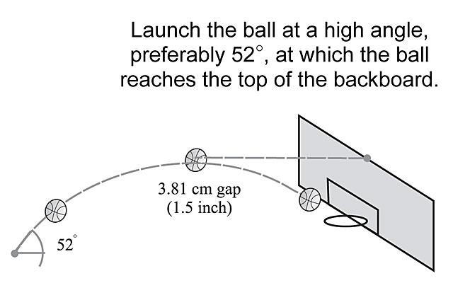

**Figure 1. Illustration of currently accepted perfect freethrow release**

The most efficient motion path may be in a variety of forms and will be one that takes advantage of the momentum applied in the shooting direction. For instance, a “Granny-shot” could be a candidate method. However, the hypothesis of this study was to see if the traditional method of shooting a free throw is the most optimal when considering reliability.

This study was limited to the motion of one arm performing a free throw shot. The arm was modeled as a rudimentary skeletal structure of the upper arm and forearm with muscular interaction. All arm properties were based on relative proportions based on the average height and weight of an NBA basketball player in 2015. Simplistic kinematic equations were used to derive the shooting path of the ball upon release. Constraints were enabled to prevent the simulation of joint hyper-extension and muscle overloading. Optimization was performed on MatLab using a Quasi-Newton Method and a Genetic Algorithm.

The concept of optimizing a free throw shot can be advantageous in a variety of different sports. If an athlete can understand the physical motions required for optimal performance, he will know exactly what to practice in order to master his sport with greater motion control and consistency.

# Methodology

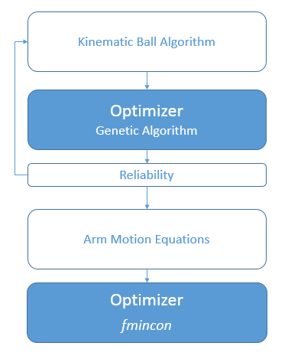This study was conducted in two parts. The first part was a kinematic model for the basketball focused on optimizing for reliability. Before taking into account the motion of the arm required by the athlete, this problem was designed to solve the exit trajectory of the ball based on a feasible release zone. The feasible release zone was considered to be within the arm reach of the player standing at full height. The data collected from this analysis was optimized through a genetic algorithm for maximum reliability. The once the trajectory of the ball satisfied the reliability conditions, the velocity and location of the ball upon release were used to create an optimal arm motion to most efficiently get the basketball to the initially position and velocity calculated from the first part. Efficiency was determined to be the motion that had minimal loss in directional momentum of the ball. The process is illustrated in Figure 2.

**Figure 2. The optimization process was divided into two: a kinematic reliability solver using a Genetic Algorithm and an optimal arm motion solver using fmincon from MatLab.**

1. **Reliable Projectile Path**

Projectile displacement equations were used to determine the most reliable initial velocity and position of the ball that resulted in a goal. In order to prevent irregular shooting results, the vertical velocity of the ball was constrained to a value that would render the ball higher than the rim (10 feet) before reaching the goal. To verify if the ball successfully made a goal, the coordinates were evaluated when it passes below the rim.

The function incorporated a Monte Carlo analysis in order to simulate human error. This analysis determined how close the shot was to being successful more than 100 times. During this process, the input variables were treated as a normal distribution. The mean distance from making a shot was then used for the objective function to determine the reliability. The normal distributions for the input variables assumed standard deviations of 1 ft/sec for initial velocity and 1 inch for initial position.

To avoid locating local minima, the initial velocity was minimized as well. This constraint realized the limitations of human control correlating directly with intensified speed. To account for this, a penalty equal to 5% of the norm of the initial velocity was added to the objective function.

This problem was solved using the genetic algorithm function in MatLab known as ga. The genetic algorithm was selected to eliminate local minima and locate the global solution. Bounds were set for the initial position using the proportionality factors of an average height NBA player in 2015. These bounds ensured that the ball could not be released from anywhere that an average NBA player could not reach. The upper bound of the initial velocity was also supplied at 50 ft/sec to prevent the ball from reaching unrealistic heights.

1. **Optimal Arm Motion**

A 3-dimensional model of the basic arm components was developed in order to provide a realistic representation of the arm's movement. The model of the arm was designed based on the proportions of an average sized NBA player 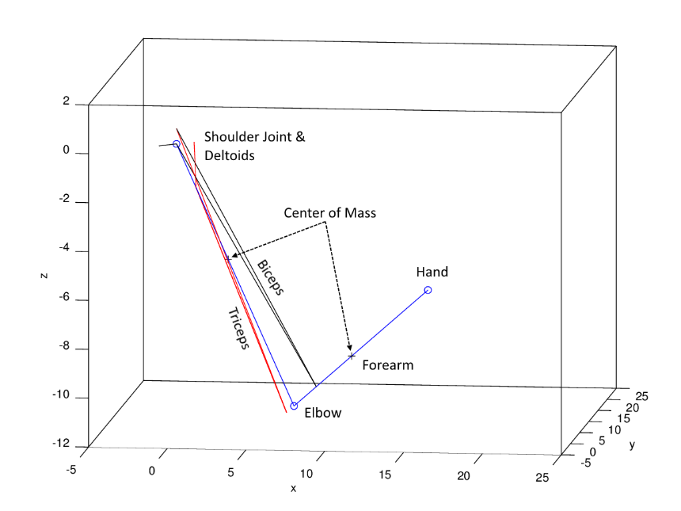in 2015, staging the height to be 6'9". The model was composed of skeletal and muscular structures which mimicked the motion of an athletic arm. The model can be seen in Figure 3. For simplification, the scope of the arm was limited to the upper arm and forearm. Acting as joints, the shoulder, elbow, and hand were connected by skeletal links. The muscle groups responsible for the arm motion were attached at the tendon locations relative to each joint. Three muscles represented the deltoids which allowed for the pivoting motion of the shoulder joint. The triceps and biceps simulated the hinged joint motion of the elbow. Each arm member acted as a cantilever beam with the mass of each member loaded at the center of mass. This static load was combined with the torque loads resulting from the arm motions. The arm model was used to stage an n-frame motion of the arm performing a free throw within a sub-second time-frame.

**Figure 3.The 3D model of the arm used for simulating arm motion. It has a skeletal structure (blue) and muscular structure (red: active, black: inactive).**

The objective function was formulated as

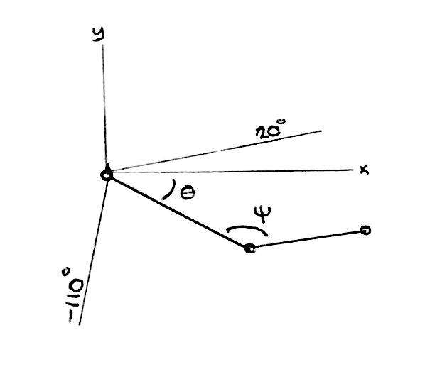

**Figure 4. The physical limitations of the arm preventing a solution resulting in hyper-extension of the arm. ψ is the angle of the elbow and θ is of the shoulder.**

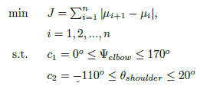

where momentum of the hand μ at each frame *i* is a function of the Cartesian coordinates of the hand x, y, and z. μ­­n was derived by the results from part 1. The angle constraints were placed to prevent hyper-extension of the arm (Figure 4). This optimization problem was solved using the *fmincon* function in MatLab.

To further investigate the arm, rotational kinetic energy was determined based on the arm in order to analyze muscular activity. To determine muscle activity, each muscle was analyzed at each frame. To determine the distributed loads on each of the muscles, the muscles first had to be determined as active or inactive. Activity was based on whether the muscle was actively contracting. A simple approach for determining this was to check if a muscle has expanded or contracted at each frame. The activity of the muscles characterized the movement.

Because the input was given as coordinates per frame, they were used to determine the angular velocity of each arm member:



The inertia for each arm member was characterized by the following



where *m* is the mass and L is the length of the arm member. These two equations were then used to solve for the rotational kinetic energy found at each joint.



Combined with the statically loaded energy, the kinetic energy was then distributed into the muscles responsible for the motion of the related joint. This process enabled a clear indication of how efficient a basketball motion is.

# Results

* 1. **Reliable Projectile Path**

When the basketball motion was solved without attempting to minimize velocity, the result produced a shot that portrayed an underhand “granny shot.” This type of shot has not typically been performed in professional basketball. This result suggested that the optimal solution given only projectile motion would be an underhanded shot. This result can be seen in Figure 5 which portrays the path of the ball using blue circles and the feasible release zone within the red circle representing the maximum distance the player could reach. The vertical red line represents a basketball player, with the top of the line indicating the overall height of the player.

**Figure 5. This is the optimal shot without penalizing the release velocity. The red circle represents the reach of the arm of the player as a feasible zone for ball release. The blue balls show the path the ball takes to make it to the goal.**

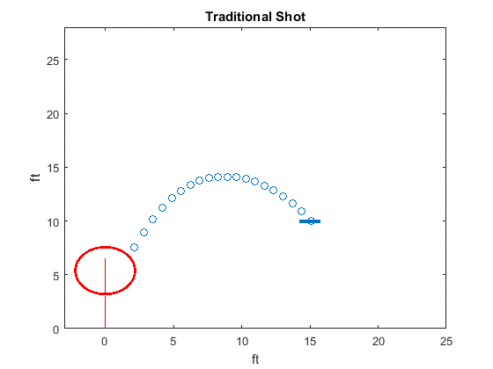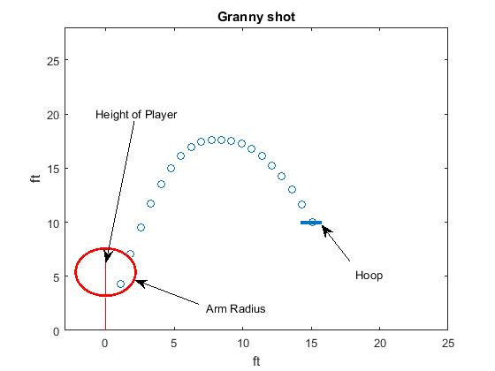

**Figure 6. This is the optimal shot including the penalty on the release velocity.**

By minimizing the initial velocity using a penalty of 5% of the norm included into the objective function, the result transformed into a traditional basketball shot (see Figure 6). A current basketball shot seen in the NBA is demonstrated by releasing the ball as far as the arm can reach in an upward angle above the head. According to Tran, the best way to shoot a basketball is with a release that has a 52 degree angle from the horizontal. The solution solved for by MATLAB had a release angle of 51.99 degrees. The perfect height of this study was determined to be 12.4 ft, with a peak height of 12.4ft.

* 1. **Optimal Arm Path**

Using the release point and velocity of the ball solved in the previous part, the solution resulted in a motion very similar to that seen in traditional basketball throw. The entire motion was 0.5 seconds. It can be seen in Figure 7. The full motion was separated by frame in Figure 9. At the same time rate, the solution discovered for the "grannyshot" produced an underhand throw seen in Figure 8.

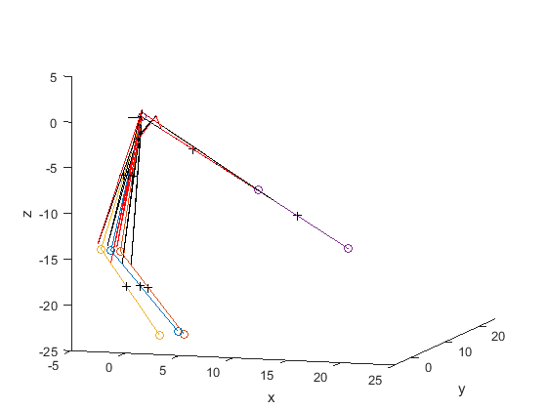

**Figure 8. The optimal arm path determined without the initial velocity penalty.**

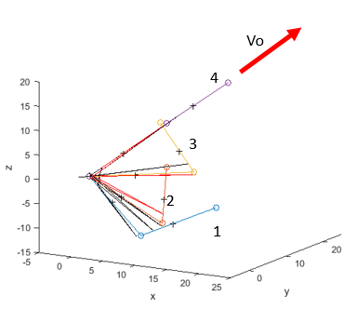

**Figure 7. The optimal arm path determined by the most reliable ball trajectory.**

To evaluate performance of the motion, the muscle activity was compared with the granny-shot solution. Each muscle was evaluated for how much it was being used. The results are seen in Figure 11 and 12. The optimal shot initially used the biceps and deltoids in order to lift the ball upward allowing for the triceps to thrust the ball in the correct direction while minimizing variation of the ball's path through the frames. The grannyshot however, required an excessive acceleration in order to match its required exit position and velocity. The values seen in the graphs were normalized by the most used muscle group. Though the triceps in the traditional shot seem to require a lot of power, the force is separated into three muscles making it not as extreme as depicted. Because of this, the grannyshot actually requires much more energy and would likely result in fatigue.

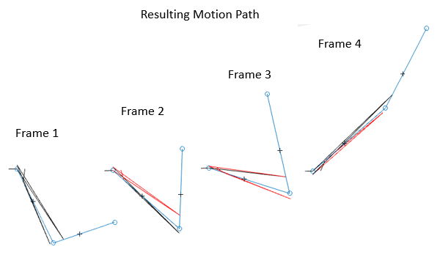

**Figure 9. The individual frames of the optimal arm path.**

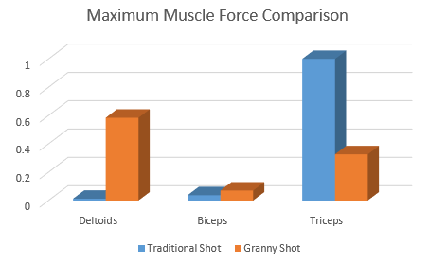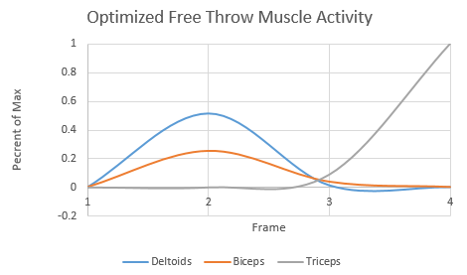

**Figure 12. Comparison graph between the muscular activity of the traditional shot and the granny shot.**

**Figure 11. The musle activity seen in the traditional shot.**

# Discussion

## The results from this study are very similar to what is accepted as perfect form. The release angle and position match the study that Tran did eight years ago, and the arm movement portion of this study match what is accepted as perfect form in the NBA today.

## The motion this study calculated to be the optimal free throw form is close enough to what accepted perfect form looks like to reach a reasonable conclusion that the accepted perfect form is optimal. However, the motions do not match perfectly. Further work is needed to build higher fidelity models to find the true optimality of free throw performance. This model only accounts for the arm motion of a player. Basketball players usually bend their knees when shooting in order to get some upward motion when they release the ball. The model developed for this study does not account for the wrist joint or any forces seen in the wrist or fingers. Another way to move forward with this study is to produce an optimizer that communicates between the two models to improve them both relative to each other. Implementing this functionality would allow for the objective function to include the repeatability of motions as well as the initial trajectory of the ball upon release.

## Even with the limitations of this study, the results are enough to support the current form of free throw shooting as optimal. This study could be used to teach developing athletes more about the physics of shooting a free throw. The fact that optimization techniques agree with basketball experience should make it easy to decide the kind of form an athlete should try to obtain in free throw shooting. However, it is likely that any player that uses tactics less optimal such as the Granny-shot, will have a poor performance given the results of basketball optimization.

## The authors hope that the concepts used in this study will be used as a starting point for gaining an understanding of the optimal motions used in sports. The concepts of this study may branch out to other sports which can supply more optimized solutions within athletic sports.

# Conclusion

The intent of this study was to explore whether or not the currently accepted perfect form for free throw shooting was also the optimal form for free throw shooting. Two optimization problems were solved for this study. The first was a problem based on the kinematics of a basketball from the point of release until it reached the basket. The results agreed with past research, in that the optimal release angle was indeed 52 degrees and the peak height of the basketball was estimated to be approximately 12.4 ft. The second optimization problem that was solved involved finding the optimal motion that would result in a velocity and release angle that was solved for in the first optimization problem. This second problem was solved using an assumption that the optimal motion would be the motion that requires the least change in momentum of the basketball. The results of solving this problem closely agreed with the accepted perfect form. Reasons for small differences in this solution were explored, and further work in this area of study was proposed. The results of this study support that the currently accepted form for free throw shooting is also the optimal way to shoot a free throw.

# References

The Anatomy of a Free Throw. (2012). Retrieved April 11, 2016, from http://www.popularmechanics.com/adventure/ sports/a7552/basketball-physics-the-anatomy-of-the-free-throw-7556633/

Tran, C. M., & Silverberg, L. M. (2008). Optimal release conditions for the free throw in men's basketball. Journal of Sports Sciences, 26(11), 1147-1155. doi:10.1080/02640410802004948

King, T. (1987). OPTIMIZATION OF BASKETBALL FOUL SHOT TECHNIQUE. American Society of Mechanical Engineers, Design Engineering Division.

Chen, J. (2014). Biomechanics Analysis of Shooting in Basketball. AMM Applied Mechanics and Materials, 685, 477-480. doi:10.4028/www.scientific.net/amm.685.477

Covaci, A., & Talaba, D. (2013). Correlations in Basketball Free Throw. AMM Applied Mechanics and Materials, 332, 509-514. doi:10.4028/www.scientific.net/amm.332.509

Tian, S. (2014). Biomechanical optimization model-based basketball field-goal percentage influence factors study. BioTechnology: An Indian Journal.

Giroux, C., Rabita, G., Chollet, D., & Guilhem, G. (2016). Optimal Balance Between Force and Velocity Differs Among World-Class Athletes. JAB Journal of Applied Biomechanics, 32(1), 59-68. doi:10.1123/jab.2015-0070

Stambolian, D., Eltoukhy, M., & Asfour, S. (2016). Development and validation of a three dimensional dynamic biomechanical lifting model for lower back evaluation for careful box placement. International Journal of Industrial Ergonomics, 54, 10-18. doi:10.1016/j.ergon.2015.12.005

Li, N., Wu, S., Wang, W., & Ye, B. (2014). Anisometry Anterior Cruciate Ligament Sport Injury Mechanism Study: A Finite Element Model with Optimization Method. AMM Applied Mechanics and Materials, 543-547, 173-180. doi:10.4028/www.scientific.net/amm.543-547.173

Bray-Miners, J., Runciman, R. J., & Groendyk, N. (2014). Methods and instrumentation for the biomechanical analysis of slalom water skiing. Proceedings of the Institution of Mechanical Engineers, Part P: Journal of Sports Engineering and Technology, 228(2), 75-85. doi:10.1177/1754337113520150

Huchez, A., Haering, D., Holvoët, P., Barbier, F., & Begon, M. (2013). Local versus global optimal sports techniques in a group of athletes. Computer Methods in Biomechanics and Biomedical Engineering, 18(8), 829-838. doi:10.1080/10255842.2013.849341

1. Mechanical Engineering Student, jon.mortensen12@gmail.com
2. Mechanical Engineering Student, jasonsporter88@gmail.com